1. Sean wants to buy a skateboard that sells for $49.99. An advertisement says that next week that skateboard will be on sale for $42.50. How much will Gavin save if he waits until next week to buy the skateboard?
2. Luis walked for 16 minutes. Natalie walked for w minutes. Luis walked twice as long as Natalie. How long did Natalie walk?
3. Jesse uses 19 beads to decorate each picture frame. In all, Jesse used 133 beads. How many picture frames did Jesse make?
4. The outdoor temperature was 18˚ at midnight. The temperature declined 7˚ each hour for the next 4 hours. What was the temperature at 4 A.M.?
5. Decide whether n = 9 is a solution to the equation 2 + n = 7.
6. The weight of a goat increased by 12 pounds is 38 pounds. Write an equation to represent the situation.
7. Twelve inches is cut from a board. The remaining board is 18 inches long. Write an equation to represent the situation.
8. Decide whether n = 3.5 is a solution to the equation 2*n*  70.
9. Denise scored 3 fewer points than Carter scored. Denise scored 18 points. How many points did Carter score? Write an equation to represent the situation. Then solve the equation to answer the problem.
10. The sales tax on a $250 computer is $17.50. Find the sales tax rate (%).
11. Last year, Mark was 46 inches tall. This year, Mark’s height is 3 inches less than Peter’s height. Peter is 51 inches tall. How tall is Mark? Write an equation to represent the situation. Then solve the equation to answer the problem.
12. There are 144 pencils in a box. If each member of the class gets 8 pencils, there will be no pencils left over. How many members of the class are there? Write an equation to represent the situation. Then solve the equation to answer the problem.
13. Jeff found 3 times as many seashells as his sister. Jeff found 39 seashells. How many seashells did his sister find? Write an equation to represent the situation. Then solve the equation to answer the problem.
14. What is the solution to the inequality?

4x  16

1. For which inequality below is x  6 a solution?
   1. 
   2. 
   3. 
   4. 
2. Last week, Robin bought a pair of shoes at a department store. He paid for the purchase using a plastic card, and the amount of the purchase was deducted from his checking account. Did Robin use a debit card or a credit card to buy the shoes?
3. Which number line represents the solution to the inequality x - 3 > 2?
   1. 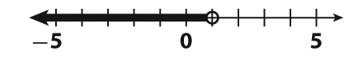
   2. 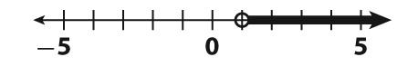
   3. 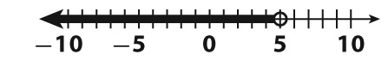
   4. 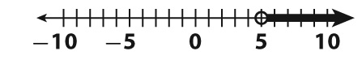
4. Michele needs 30 ounces of pecans to bake some pies. Pecans are sold in 4-ounce packages. Write an inequality that could be used to find the least number of packages of pecans she has to buy?
5. Which number line below represents the inequality x 4?
   1. 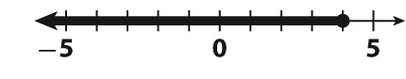
   2. 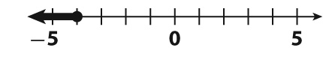
   3. 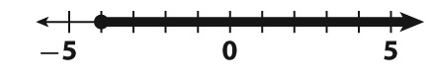
   4. 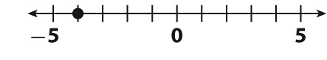
6. Write the inequality represented in the number line below.

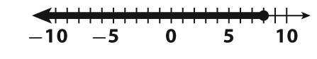

1. Find the first operation you should perform to evaluate the expression below.? Then solve.

9 × 4  (20  22)

1. The annual median income for a veterinarian is $82,040. The annual median income for a veterinarian assistant is $22,040. Over 10 years, how much more than a veterinarian assistant can a veterinarian earn?
2. Solve the inequality and solve it on the number line.

*x*  8 ≥ 5

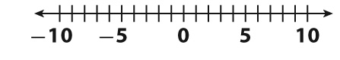

1. Every month, the bank withdraws $15 from Betsy’s checking account as a service fee. Betsy has budgeted $75 for the next few service fees. For how many months will the service fee be covered?
2. Use the grid

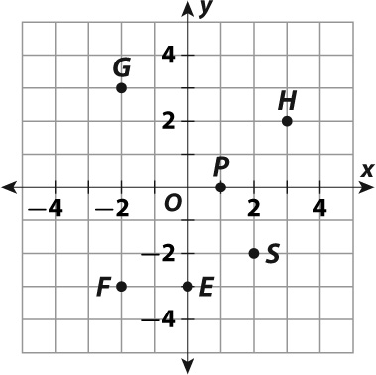

* 1. Which point is located at (-2, 3)?
  2. What are the coordinates of point S?
  3. Which points are on the axes?

1. What is the solution to the inequality: -8m ≥ 40
2. How many centimeters are there in 5 meters?
3. The table shows a bicycle rider moving at a constant rate of speed.

What is the dependent variable in this situation?

* 1. rate
  2. time
  3. speed
  4. distance

1. Use the ordered pairs shown in the table.

**Lakeside Canoe Rentals**



Write an equation to represent the data in the table.

1. Use the grid

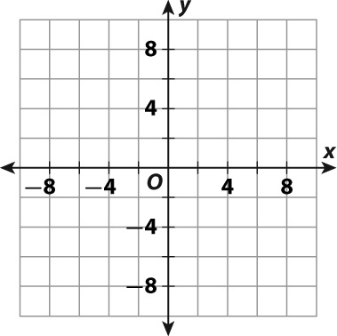

* 1. Graph P(-6, -4), Q(-4, -6), and R(6, -4).
  2. In which quadrant are P and Q?
  3. Graph points at (6, 6), (6, 0), and (6, 2). What do these points have in common with point R?

1. What is the interquartile range of the data represented in the box plot below?

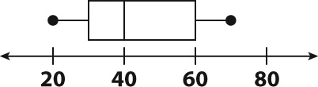

1. What is the median of the data represented in the line plot below?

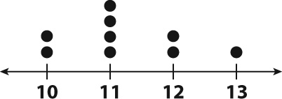

1. What is the range for the data shown in the stem-and-leaf plot below?

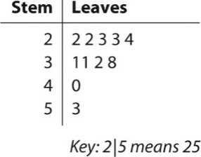

1. For the data set below, calculate each and find which measure is greatest?

{20, 25, 30, 31, 32, 45, 45, 80}

* 1. mean
  2. range
  3. median
  4. mode

1. Doug is tiling a section of wall below the cabinets in his kitchen. He is using 15 green tiles and 20 blue tiles. List two combinations of green tiles and blue tiles that have the same ratio as the number of tiles Doug is using.
2. Which of the following situations describes the use of an ATM?
   1. Abby purchased an item and paid for it when the bill came in the mail.
   2. Abby wrote out an amount for an item and gave it to a cashier.
   3. Abby entered a PIN to begin a transaction and received an amount of cash.
   4. Abby balanced her checkbook.
3. In the table, Mr. Smith recorded the height of each student in his class.



* 1. Draw a stem-and-leaf plot to display the data. Let 5|1 represent 51 inches.

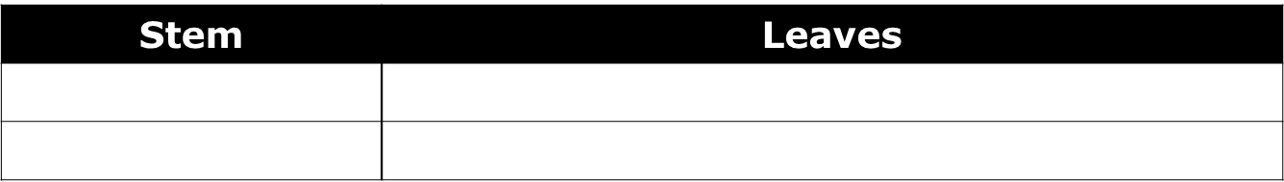

* 1. What is the mean height of the students in Mr. Smith’s class?
  2. What is the median height of the students in Mr. Smith’s class?
  3. What are the modes of the data?
  4. Draw a box-and-whisker plot to display the data.  
       
       
     
  5. What is the interquartile range for the data?

1. Carrie is sewing a quilt that includes 20 purple squares and 12 orange squares. What is the ratio of purple squares to orange squares? If Carrie wants her quilt to have 30 purple squares, how many MORE orange squares will she need to make?
2. Which of the following can have a positive effect on your credit score?
   1. owing more money than you earn
   2. losing your job
   3. paying your bills on time
   4. having a high debt-to-income ratio
3. Complete the sentence: 24 is ______ % of 60.